STIs assessment

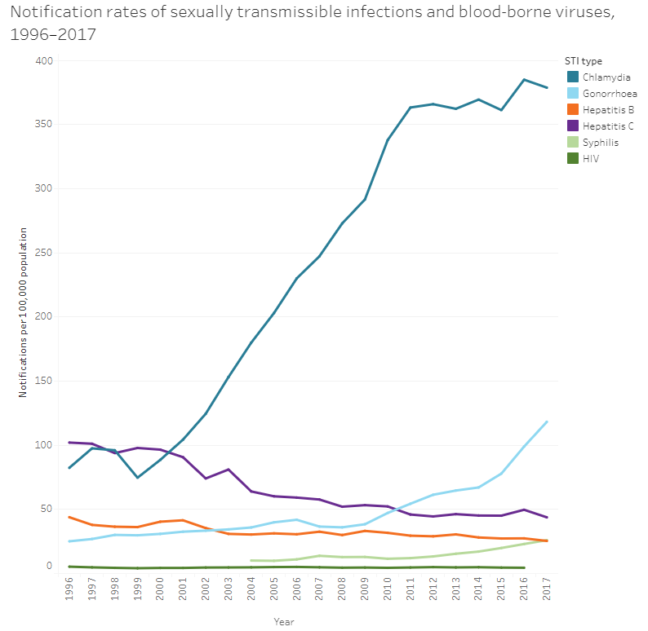

Table S3.19.1: Notification rates of selected notifiable diseases, Australia, 2013–2017
Notifiable disease | 2013 | 2014 | 2015 | 2016 | 2017
Influenza | 122.3 | 288.1 | 421.8 | 375.3 | 962.7
Gonococcal infection | 64.4 | 66.8 | 77.6 | 98.7 | 93.7
Campylobacteriosis | 63.5 | 84.9 | 94.5 | 99.8 | 88.2
Chlamydial infection | 362.0 | 369.3 | 352.5 | 371.5 | 312.0

Table S3.19.3: Notification rate for new syphilis infections and invasive meningiococcal disease, type W, 2008-2017
Year | Number of notifications | Notification rate (per 100,000 population)
 | New syphilis infections
2008 | 1320.0 | 6.1
2009 | 1289.0 | 5.9
2010 | 1098.0 | 5.0
2011 | 1255.0 | 5.6
2012 | 1537.0 | 6.8
2013 | 1770.0 | 7.6
2014 | 2070.0 | 8.8
2015 | 2758 | 11.6
2016 | 3465 | 14.3
2017 | 4365.0 | 18.0

